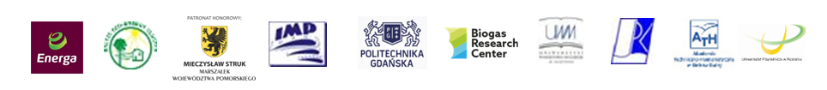

**Baltic Biogas Forum**

**16th-17 th June 2016**

**Application Form**

**First name: ..........................................................................................................**

**Last name: ..........................................................................................................**

****Institution/Country: …........................................................................................****

****..............................................................................................................................****

****NIP : ......................................................................................................................****

****Specialization/Position: ....................................................................................****

**Telephone: .........................................................................................................**

****Fax: ……………...................................................................................................****

**e-mail: …………...................................................................................................**

**I have paid the conference fee 1.107,00 PLN** (900 PLN + 23% VAT)

**via bank transfer to the IMPLASER bank account.**

**Bank Millennium o/Gdańsk   
SWIFT CODE: BIGBPLPWXXX**

**No. PL04 1160 2202 0000 0000 5069 7879**

**and please use reference:**V Baltic Biogas Forum + name

**Please send the filled-in application form :**

**By post:**

**IMPLASER** **ul. Fiszera 14, 80‑231 Gdańsk, POLAND**(with reference on the envelope: V Baltic Biogas Forum)

**By fax: 0048** **58 341-61-44** **By e-mail**: **biogaz@imp.gda.pl**